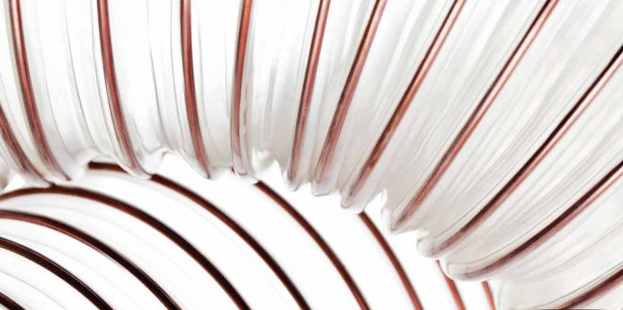

**INSTALLATION GUIDE of PU HOSES**



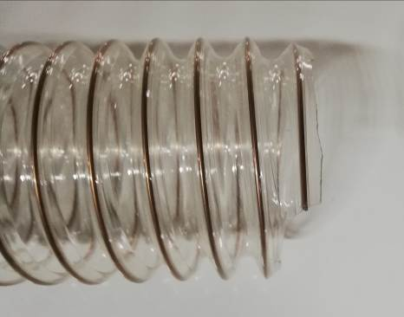

1. Determine the required hose type and length by avoiding twisting, stretching and tension.

2. Ensure proper layout and eliminate excess bending stress by taking care of bending radius data.

3. During the installation of arc form, bending Radius must be fallowed.

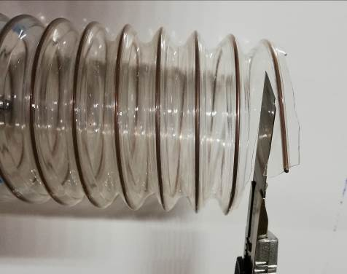

4. Cut the hose straight and perpendicular by using sharp cutting tool approximately 30 mm from the edge. Be careful while you are cutting the hose and pay attention to the sharp edge of wire.

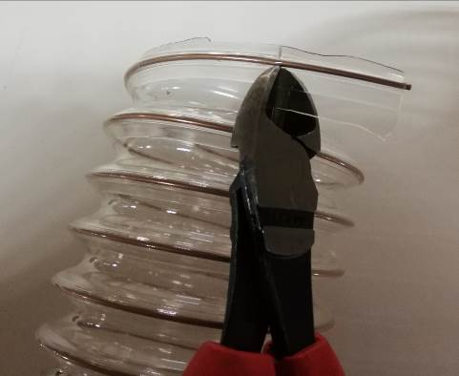

5. Take off the wall through / over the wire. After cutting, inside of the hose must be wiped off.

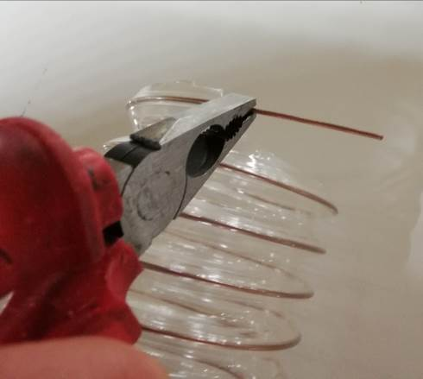

6. Bend the bare wire by 90° so that it will be parallel with the connection element.

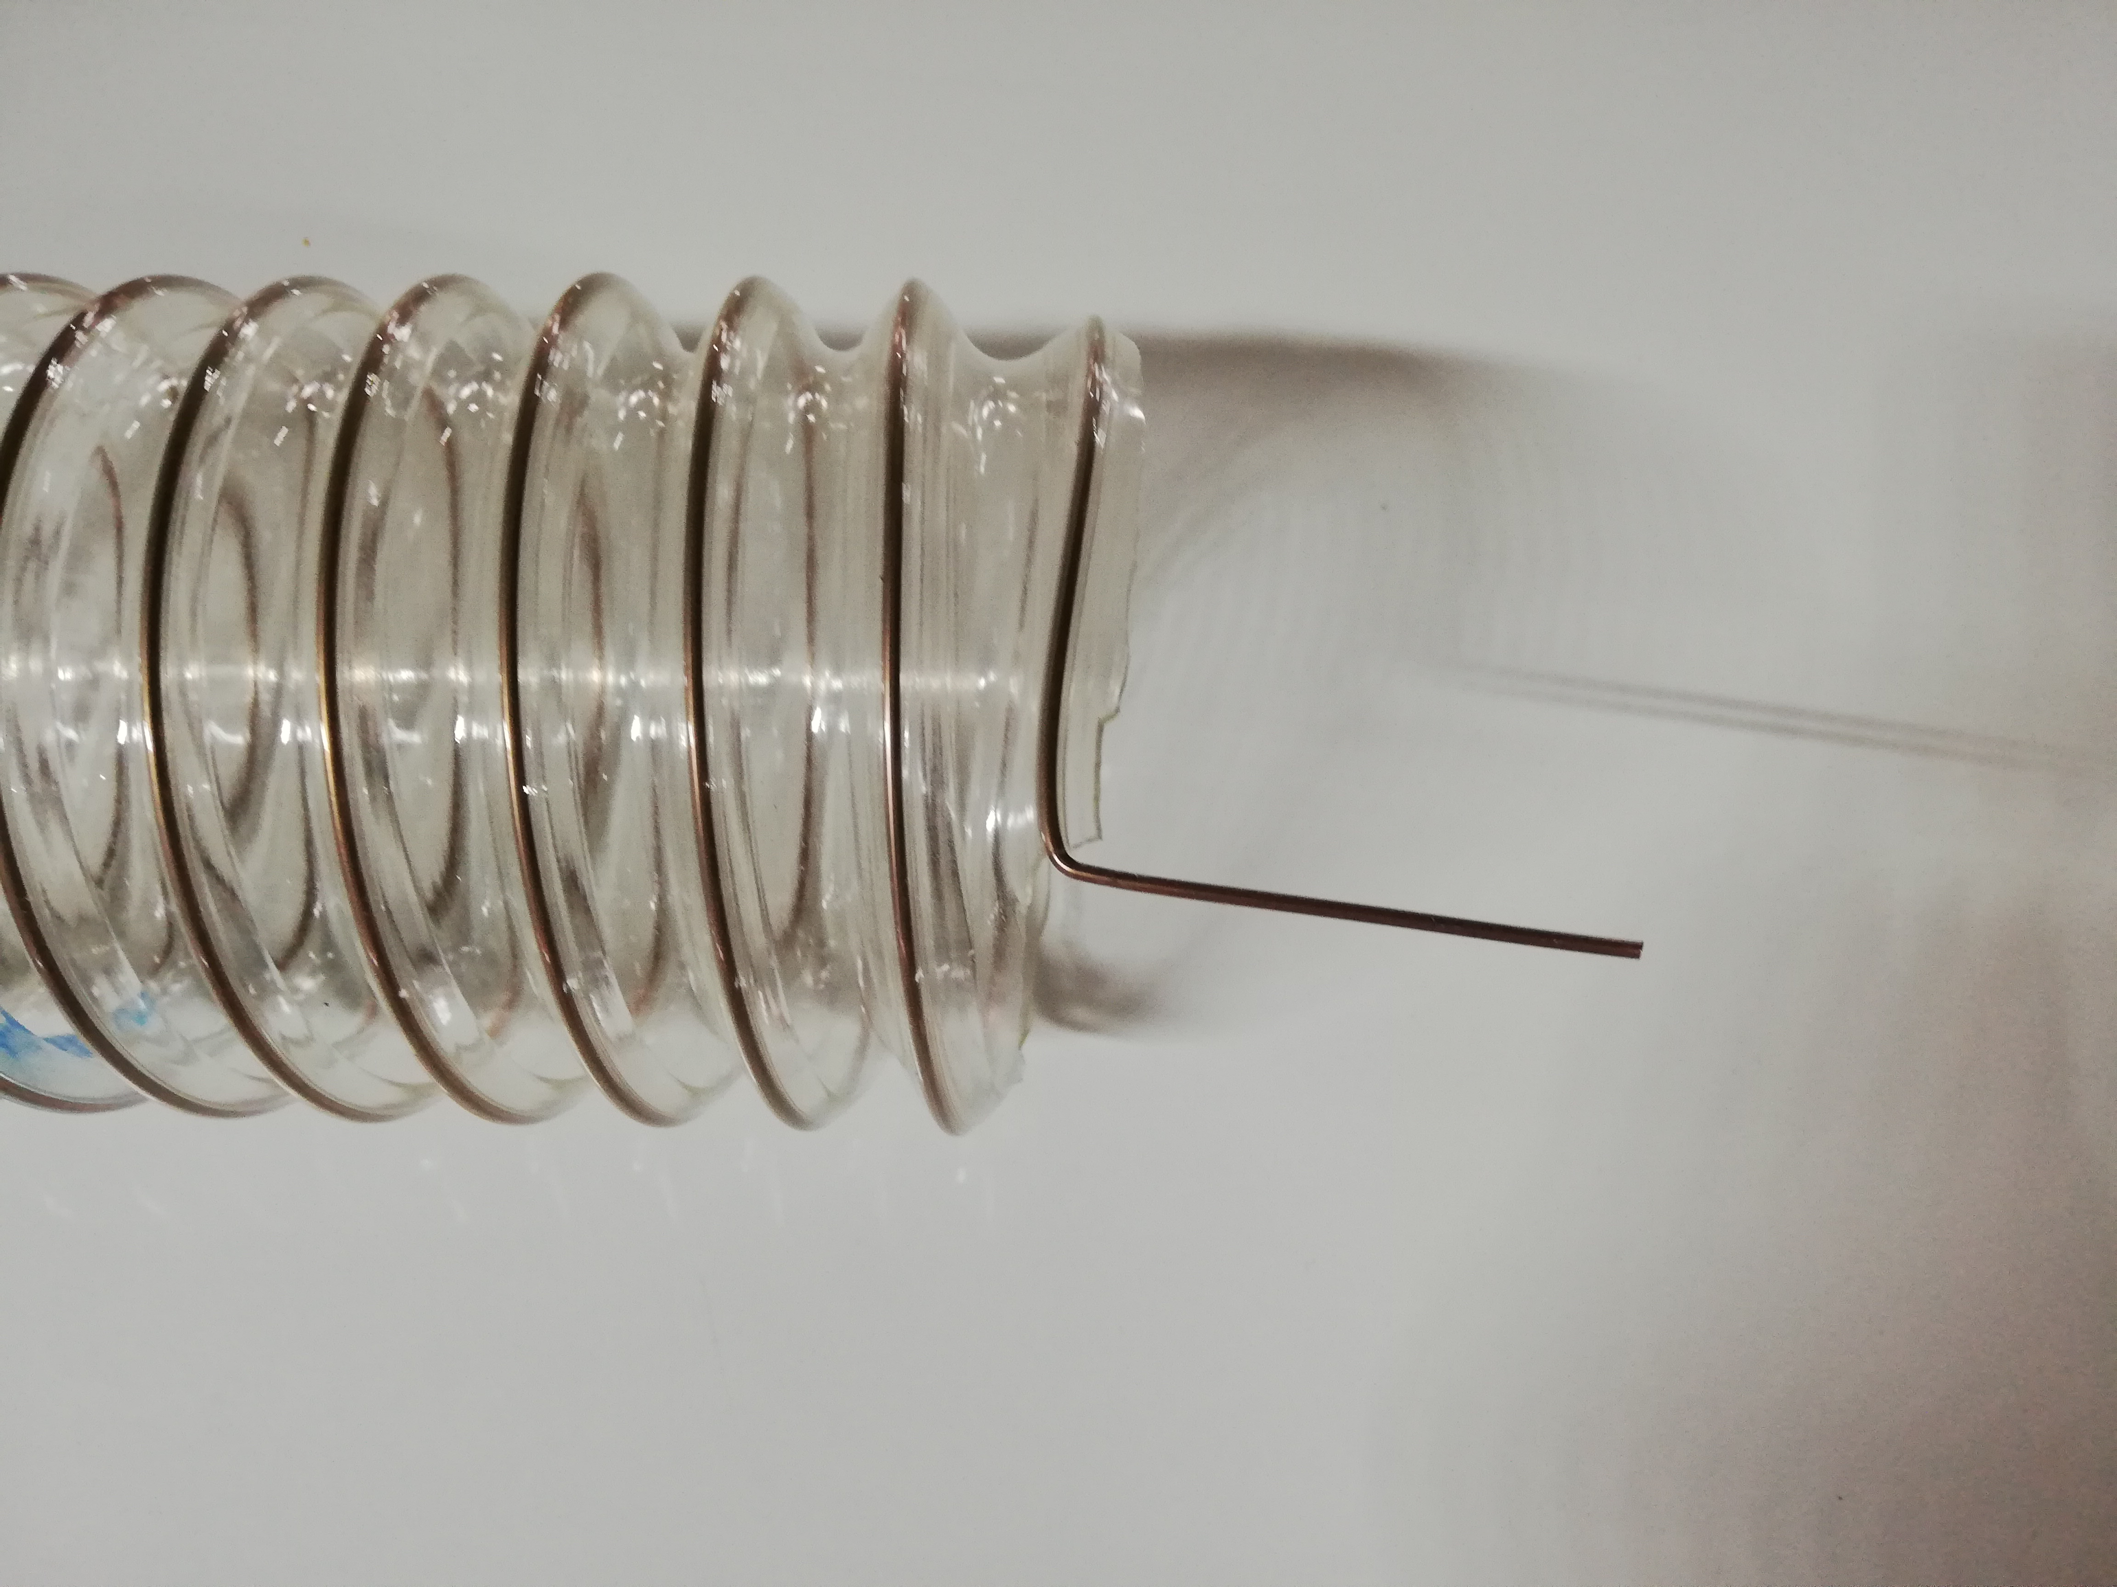

7. Adjacent picture shows the form of the wire after bending.

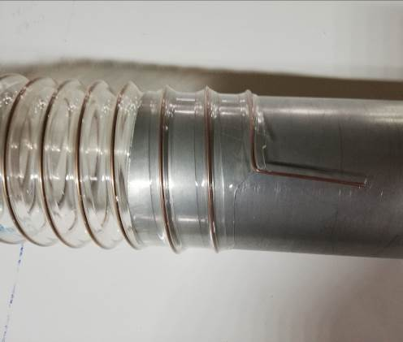

8. Connect the hose to the proper sized connection element.

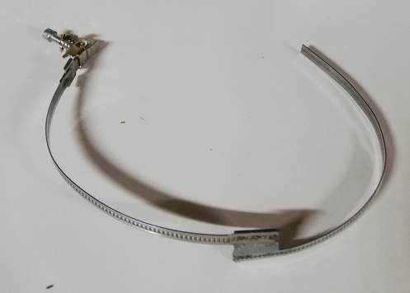

9. Choose the correct quality of assembly components.

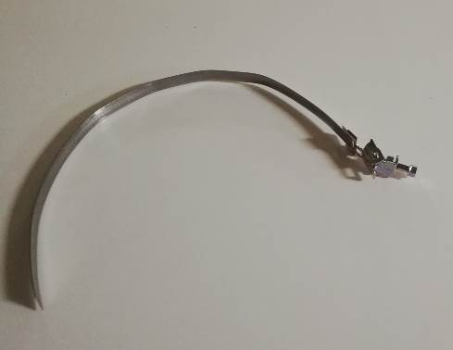

10. Hose connection clamps and wire connection clamps have different feature. For this reason, please ensure that you use the right connection clamp for the hose and wire.

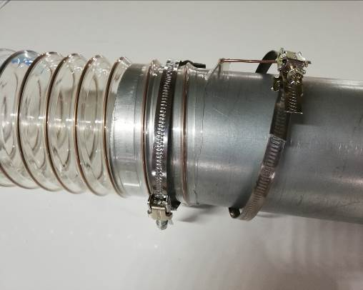

11. Attach the connection clamps to the connection element and tighten the screw of the clamps so that connection is steady.

12. Below pictures show how the final installation will be look like on both sides. To ensure of grounding to prevent the possible danger comes from static electric on the connection element, touching of the bended wire onto the surface must be secured.

